Day Trip to Menagesha -Suba Forest
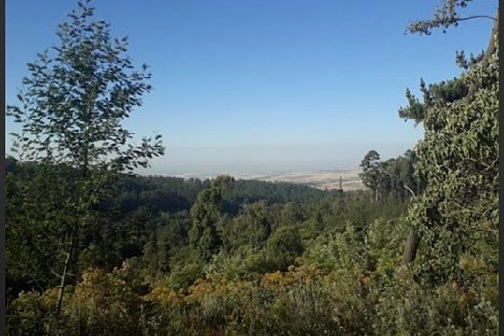
Duration-Full days
Mode of transportation: - Car
Menagesha suba forest
We will meet you at the airport or your hotel then we will drive to Menagesha suba forest which was originally protected by Zera Yacob (1399 –1468) he was the Emperor of Ethiopia. the total area of the park is around 2500 hectare and the forest have a natural big trees like juniper us and Eric arboreal and is one of the tourist destination for a day trip from Addis Ababa because of its remarkable natural indigenous tree species and some endemic birds with some species mammals like endemic antelopes of Minilk Bushbuck. after the visit return to Addis Ababa.

